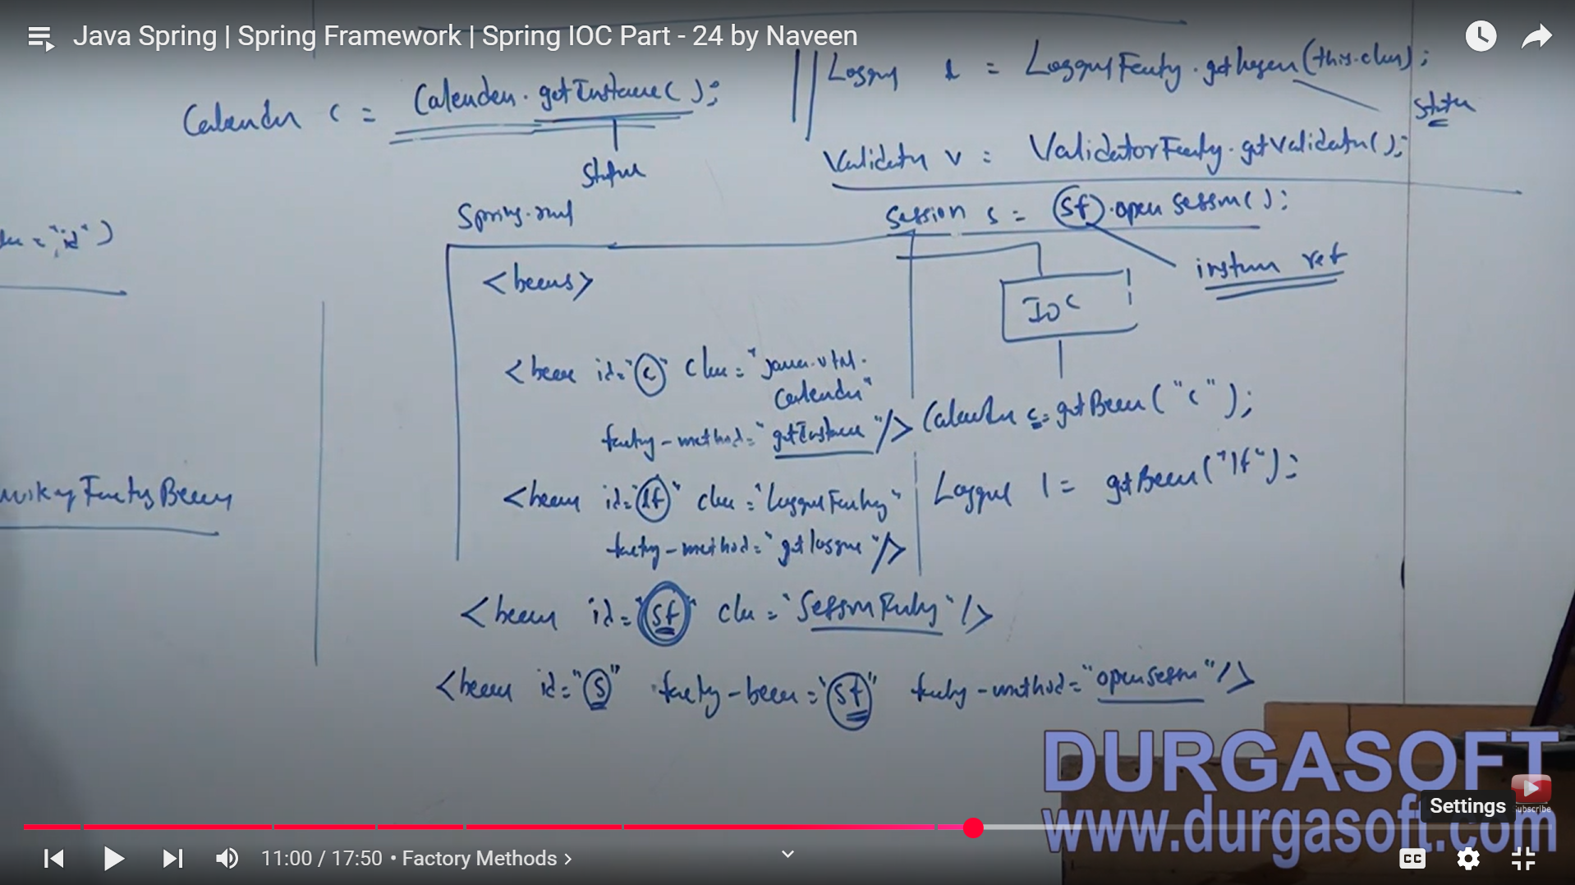

Logger l = LoggerFactory.getlogger(“”);

For the logger we create the object using the Factory methods,

Session s = sf. openSession(“”);

but with session we need to create the objects using the instance object, so we need to create the session factory object first.

FACTORY BEAN:

It’s an interface which allows to create the objects:

getObject(), getObjectType(), isSingleton()

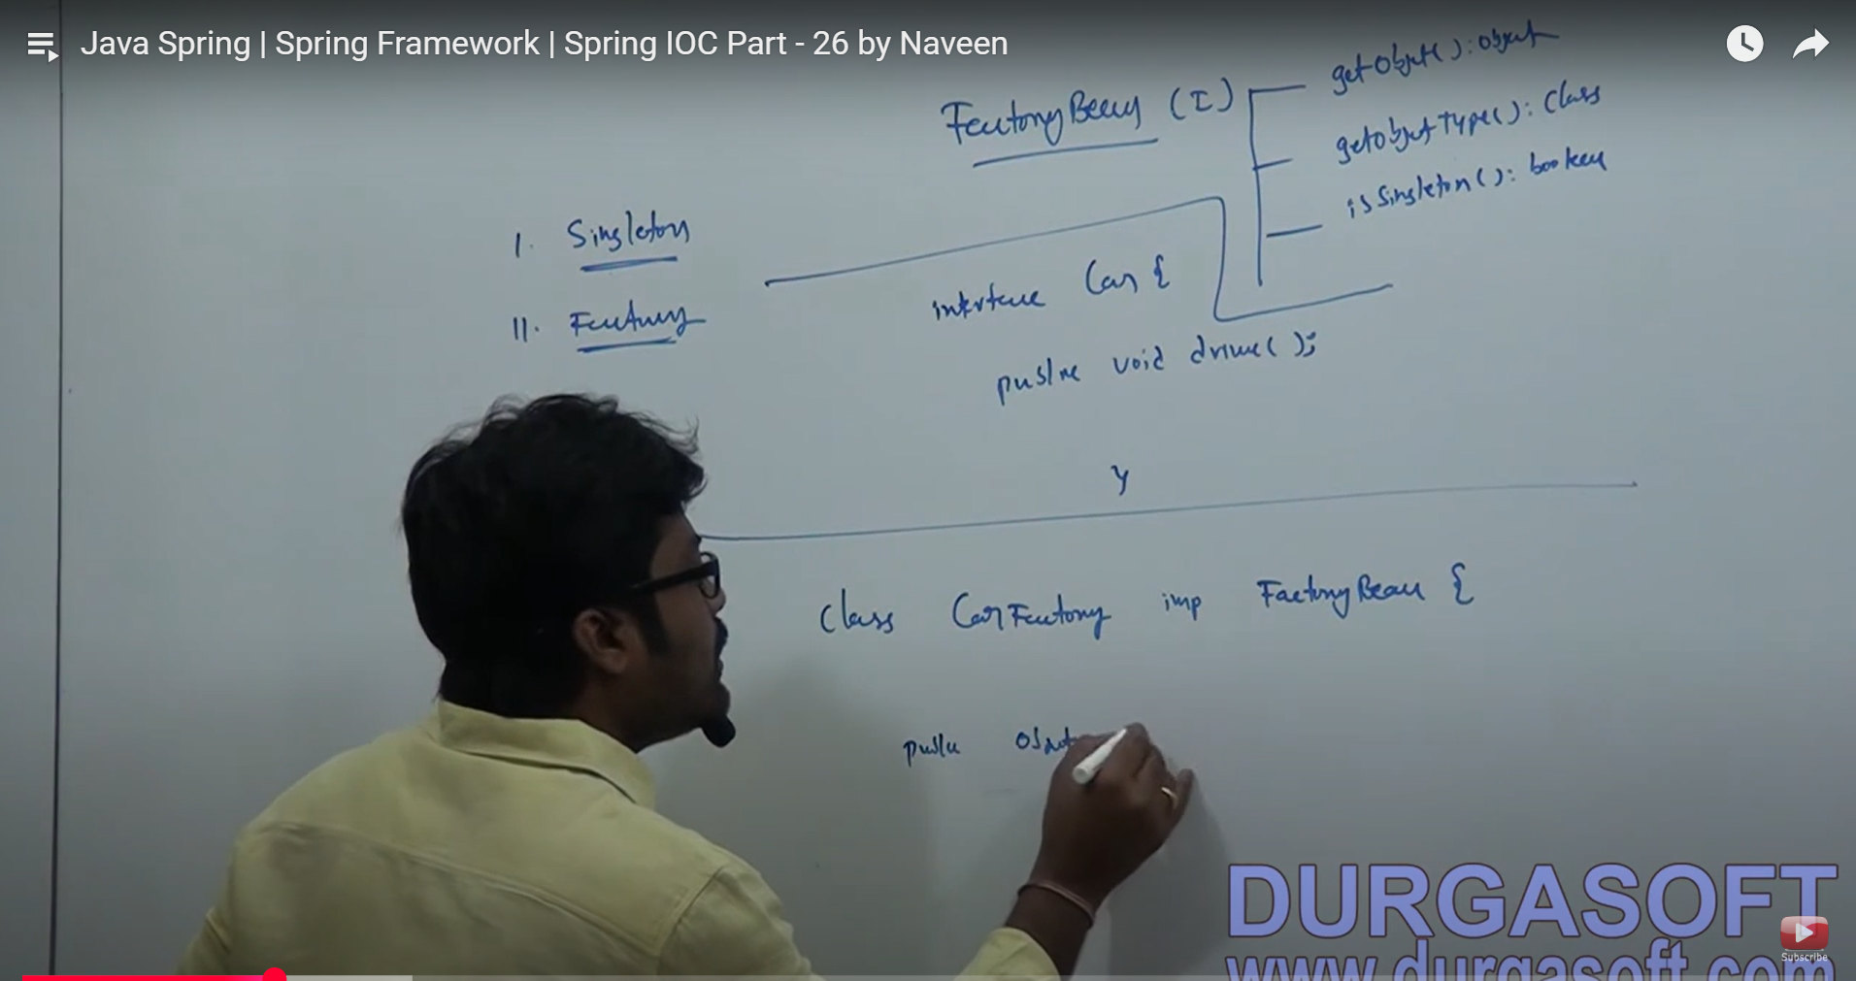

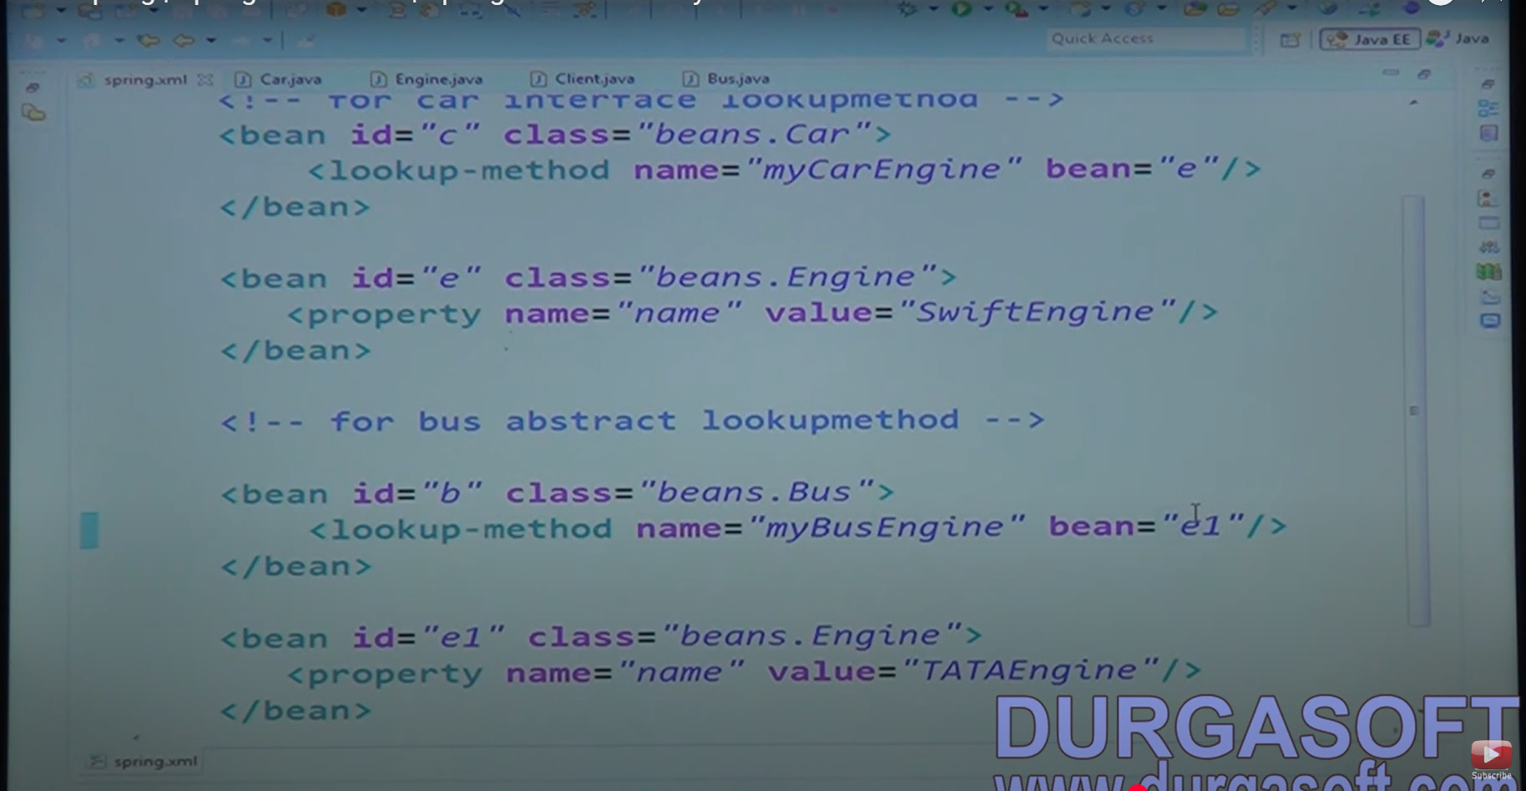

Lookup method to create the implementation using the interface:

Public interface Car{

Public ENGINE myCarEngine;

}

AND following is the ENGINE class:

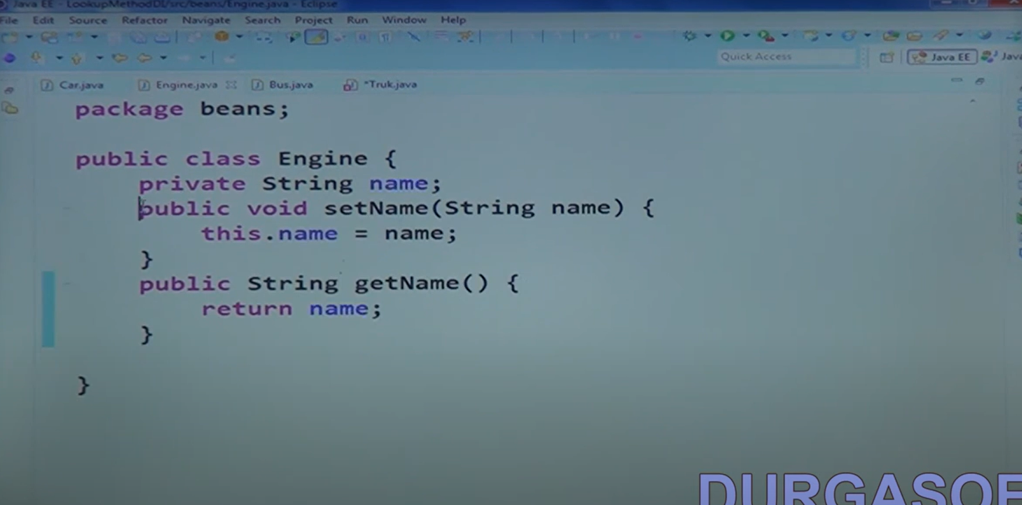

If you want to use init and destroy method in you 100 classes, then instead of using annotations on every method, you can use that tag in the parent bean tag.

<beans default-init-method = “init”

default-destroy-method = “destroy”>

SPRING BOOT:

Stand alone production gradle application.

Spring boot contains embedded servers and does not involve configurations.

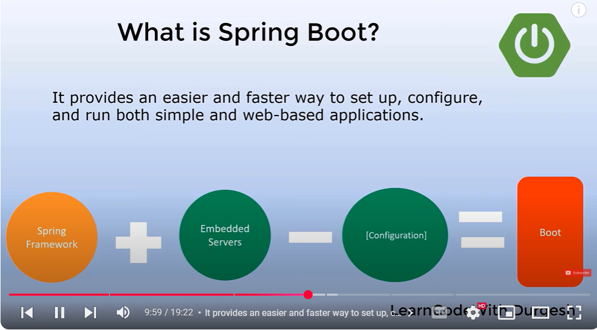

Convention over configuration,

JPA: EntityMANAGAERFactory, EntityManager

CRUDREPOSITORY: Databaseoperations

JPAREPOSITORY is a child of CRUD repositories which provides extra features.

JPQL query is written as follows:

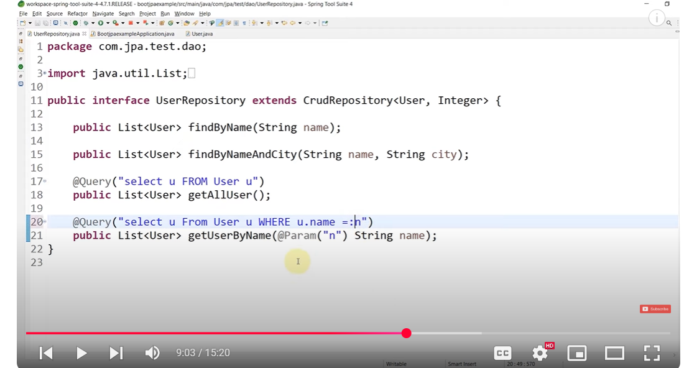

Native query in spring boot is written like this one:

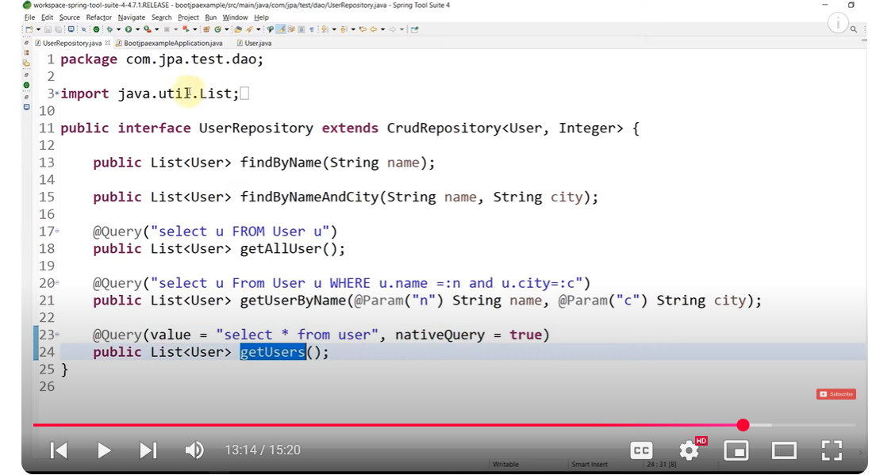

SPRING BOOT DEV TOOLS:

1. Property defaults. Makes cache false.
2. Automatic restart: Automatically scans the classpath and restarts the class.
3. Live reload:
4. Remote applications

JSONManagedReferences

JSONBackReferences

These entities are used in the bidirectional mappings, and JSONBackReferences is used on the child object while JSONManagedReferences is applied on the parent object.

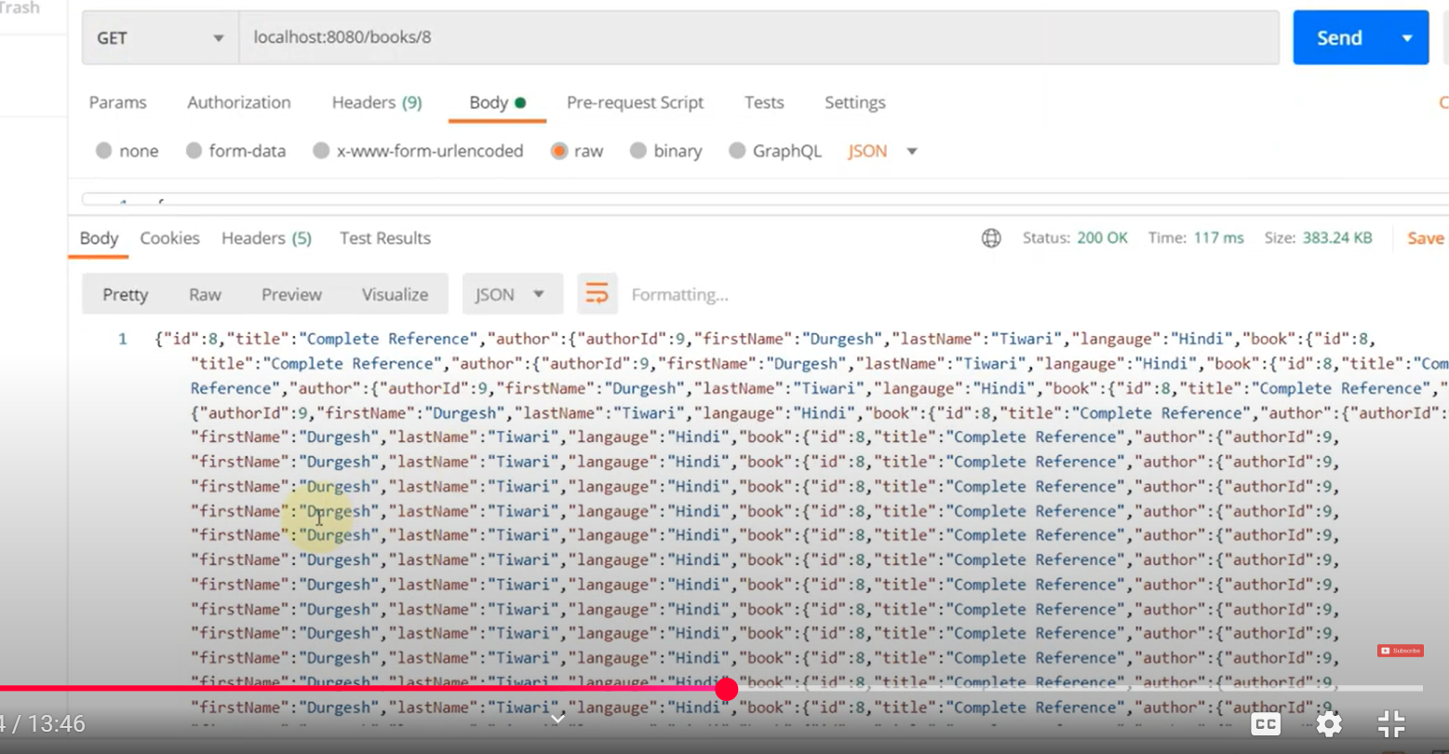

As while searching for one object, it just iterates and iterates back from parent to child and child to parent, and so-on.

File uploading mechanism:

Spring.servlet.multipart.enabled = true

For uploading a file, we need to use:

@PostMapping(“”)

Public ResponseEntity<String> uploadFile(@RequestParam(“file”) Multipart file){}

Method to upload the file:

Files.copy(IN, TARGET, OPTIONS)

Thymeleaf template:

Fragments: To resuse the elements on the page, we use the fragements, example: we need to include the header and footer on every page, so we can define them at some other class to use them in every component we use.

Include, insert or replace we can use that

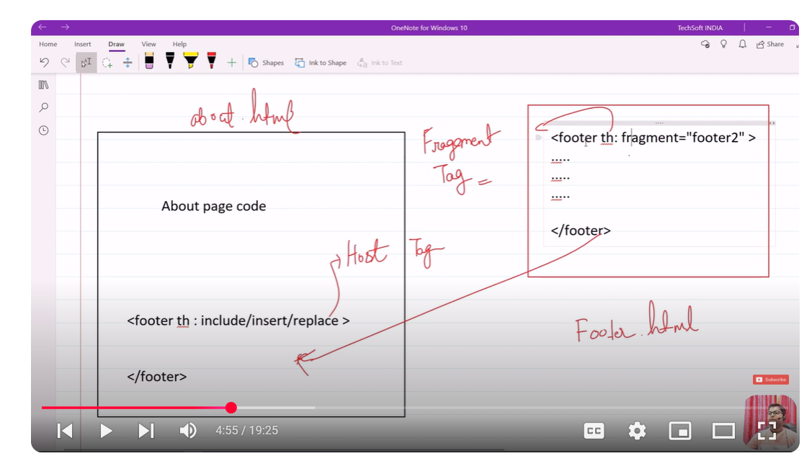

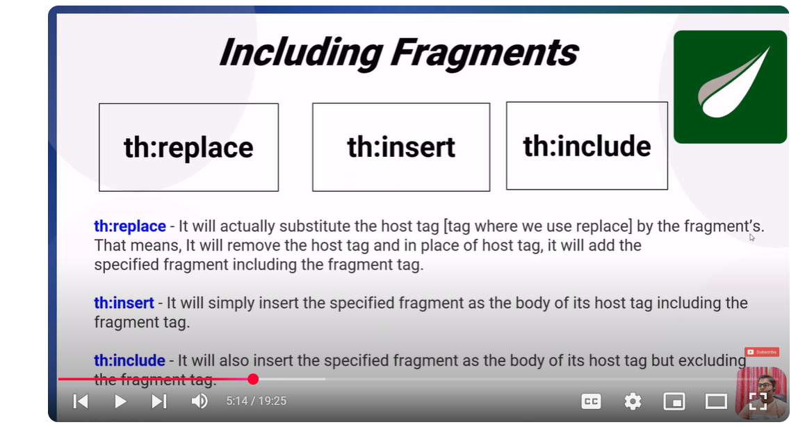

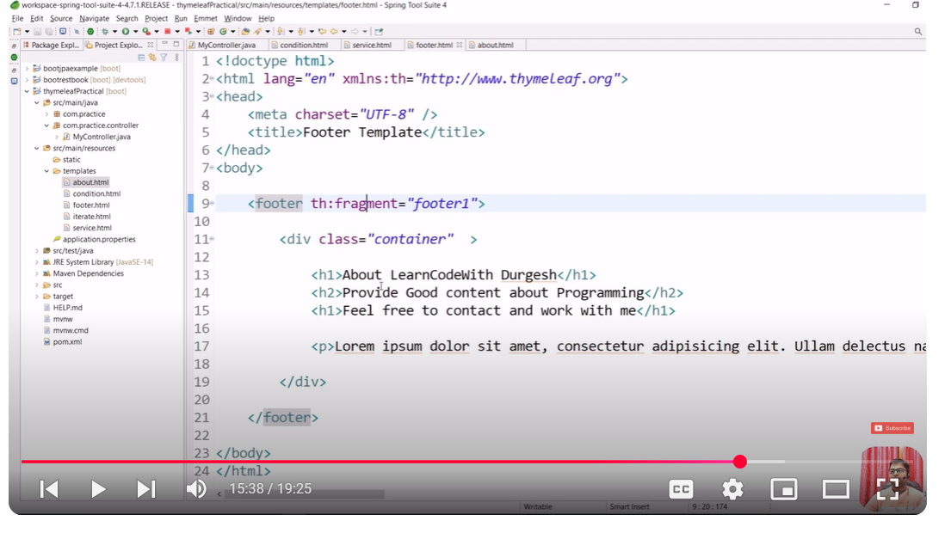

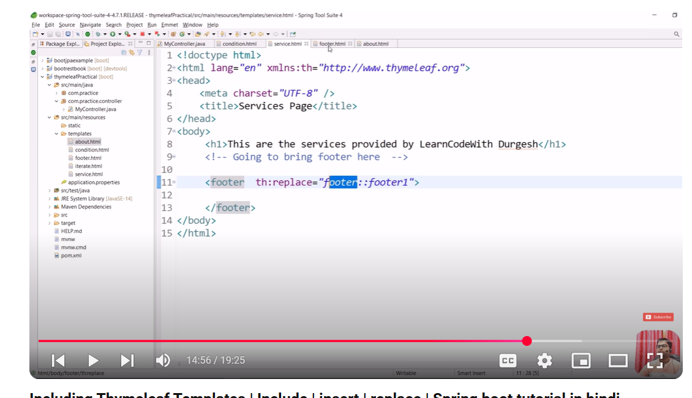

To set up the validations, we need to use the javax.validation, Validation API.

And also the hibernate validator as following:

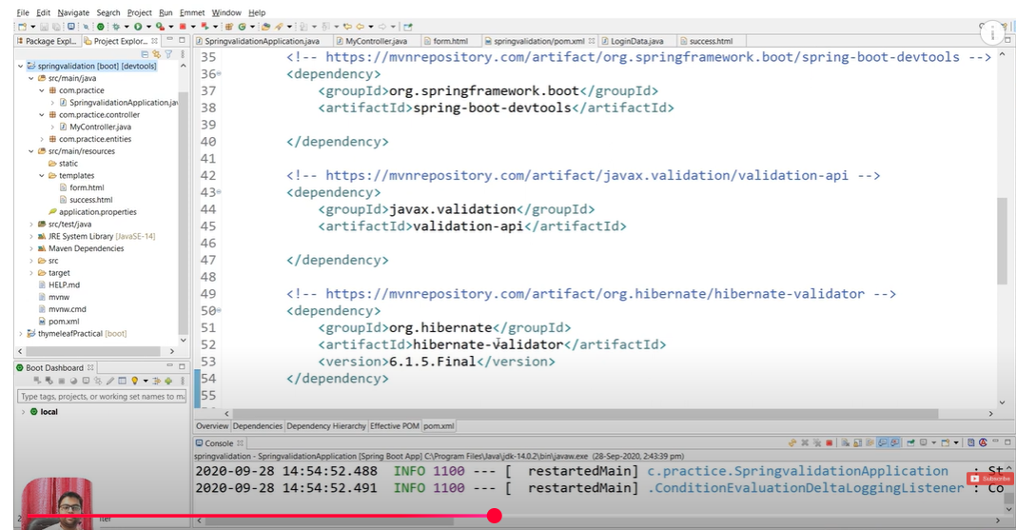

In the controller, we need to use @valid and the BindingResult to setup the errors on the page.

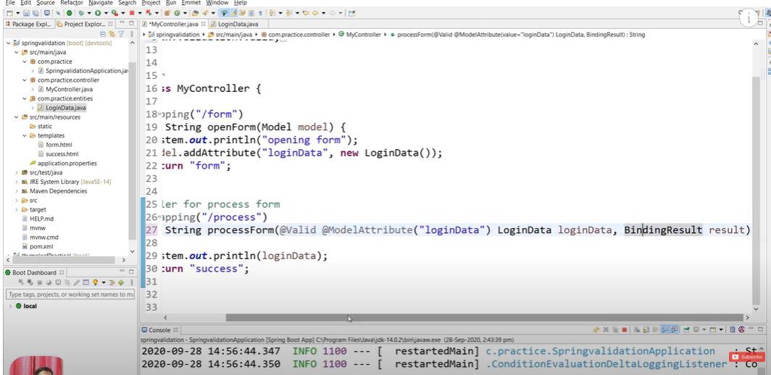

Following are the validations on the thymeleaf page:

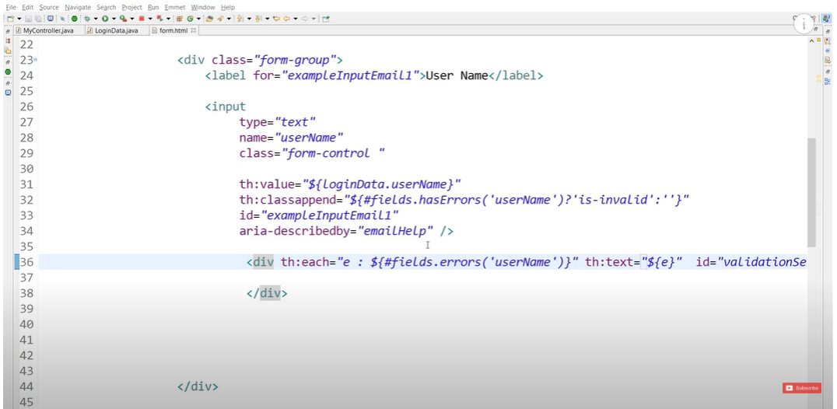

On the model page:

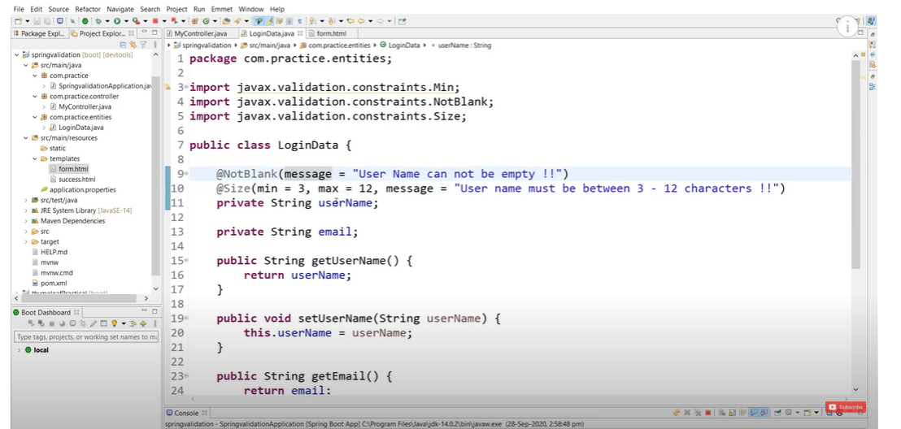

Regex expression on the email page:

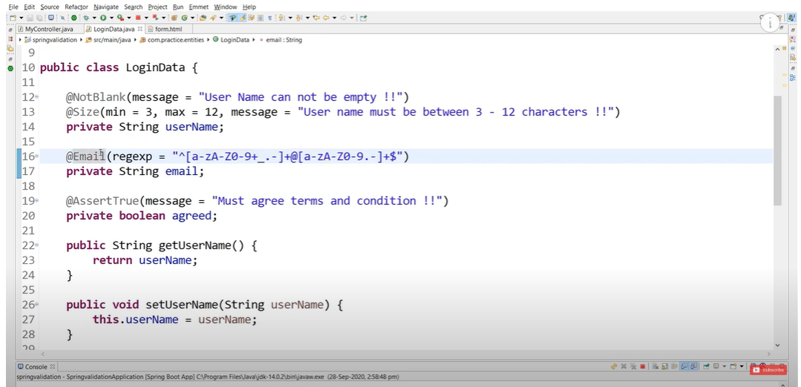

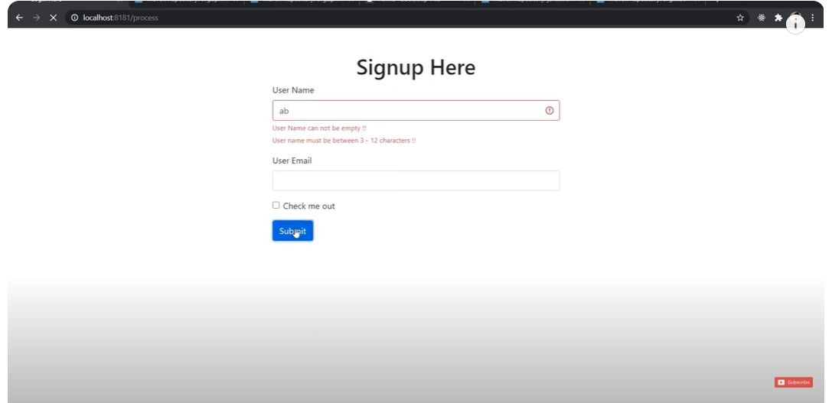

To validate the Boolean value, we need to use the @AssertTrue:

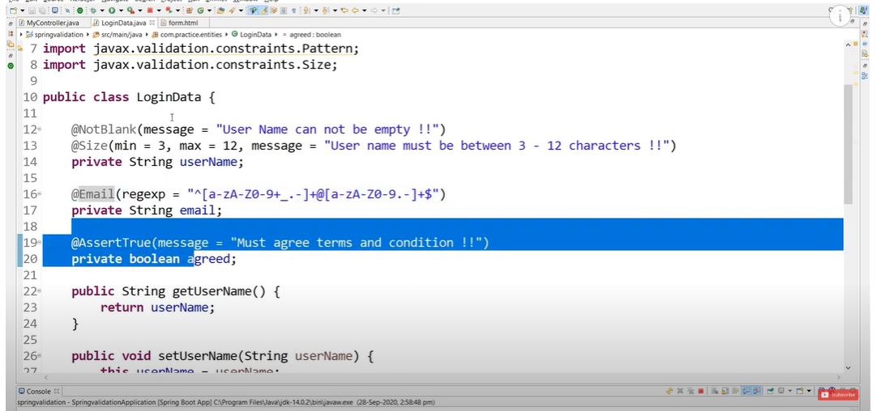

SPECIAL CASE:

If we not use the mapping mapped by, then the following tables will be created:

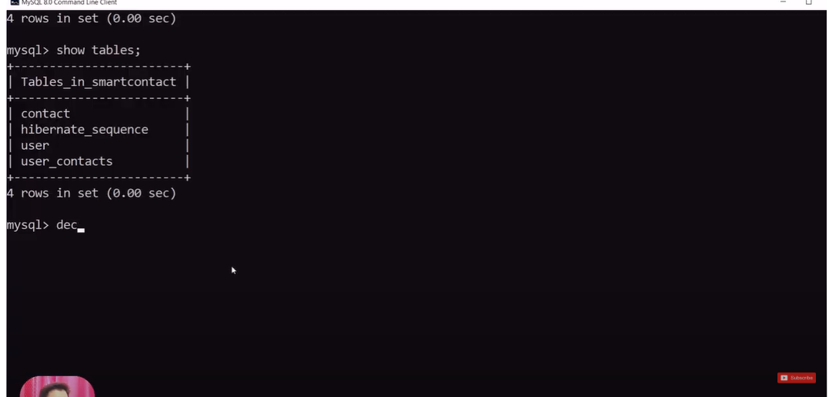

To make sure that there is no additional table for the @onetoone and @manyToOne mapping then we need to use the following:

@ManyToOne looks like following:

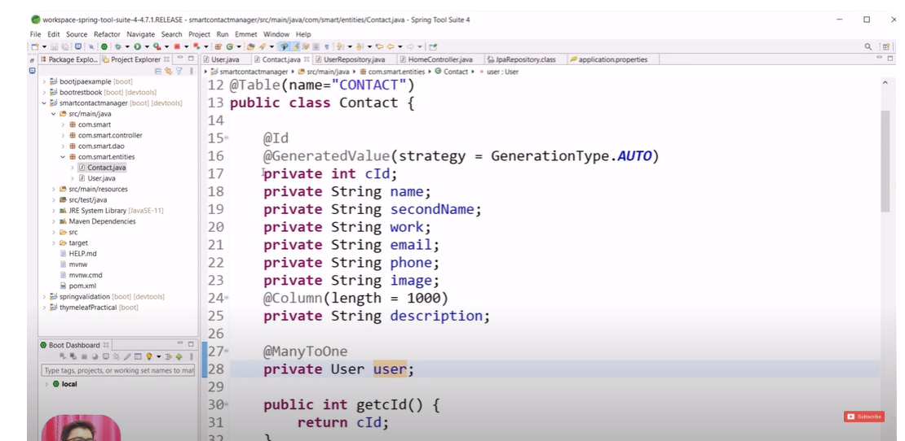

@OneToMany looks like:

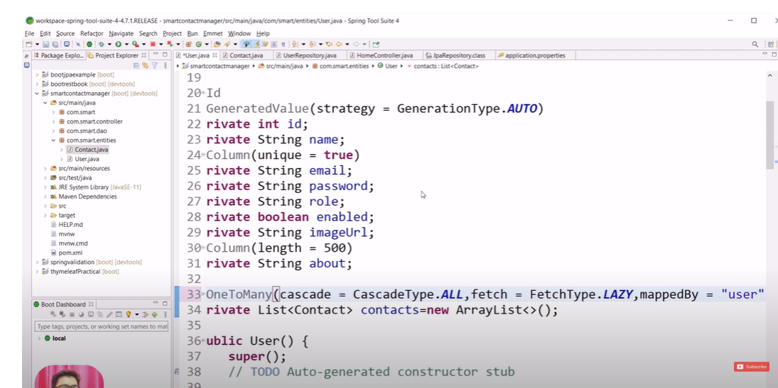

Then in this case, no additional tables will be created.

To handle the checkbox, we can include the @RequestParam (value = “name”, defaultValue = “false”)

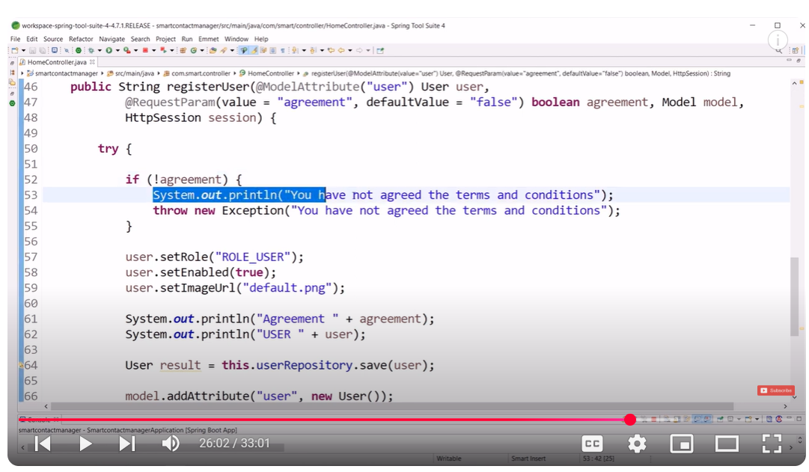

To send out the message, we need to add that in the session and send on the thymeleaf page as follows:

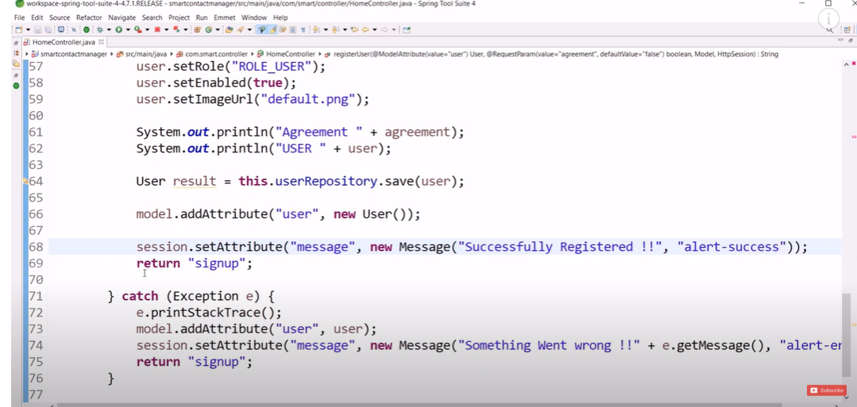

To display the message on the front end, we need to use the following:

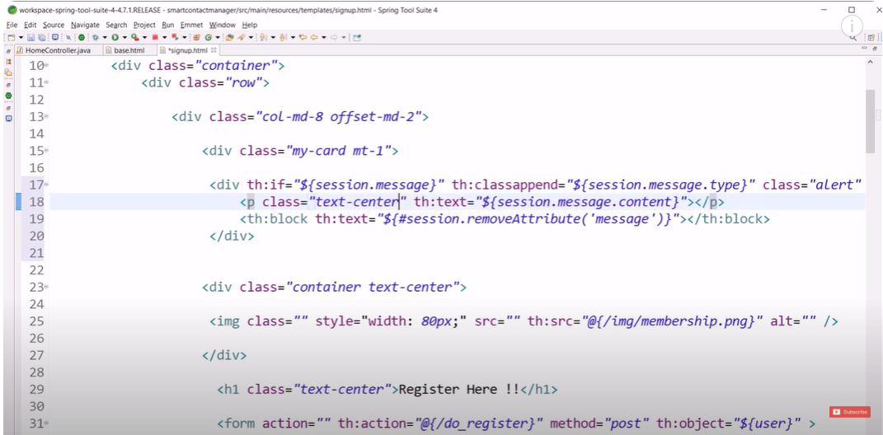

SPRING BOOT SECURITY:

When you add the spring-starter boot security in the pom.xml, there is a login page that pops up when you try to access any API.

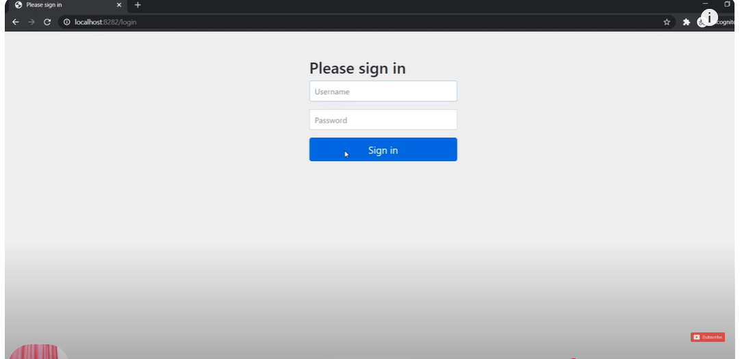

To use the Spring security in our project, we need to do the following:

1. Provide the implementation of the UserDetails interface and use the class to extend that.
2. Provide the implementation of the UserDetailService interface and use the class to extend that.
3. Need to use the security configuration class, WebSecurityConfigurerAdapter to use the services.

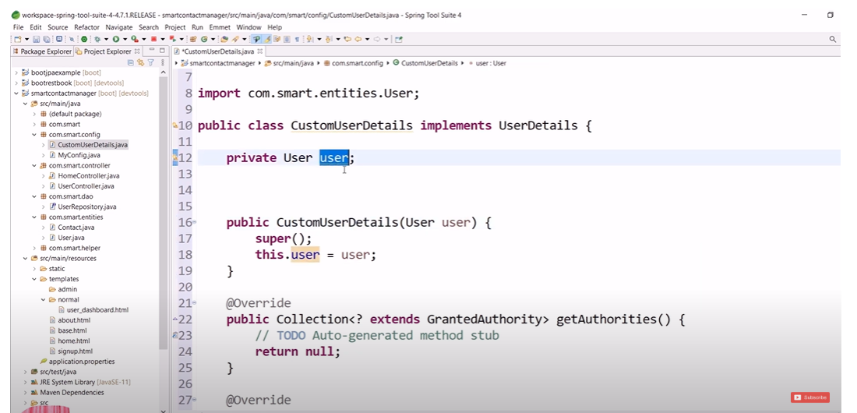

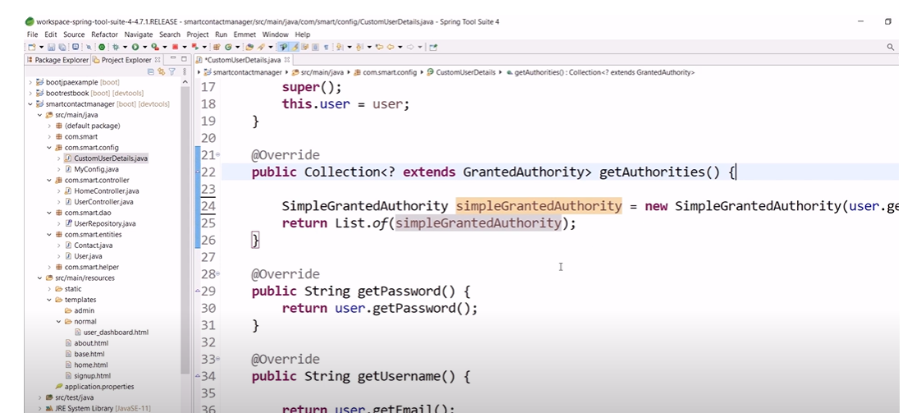

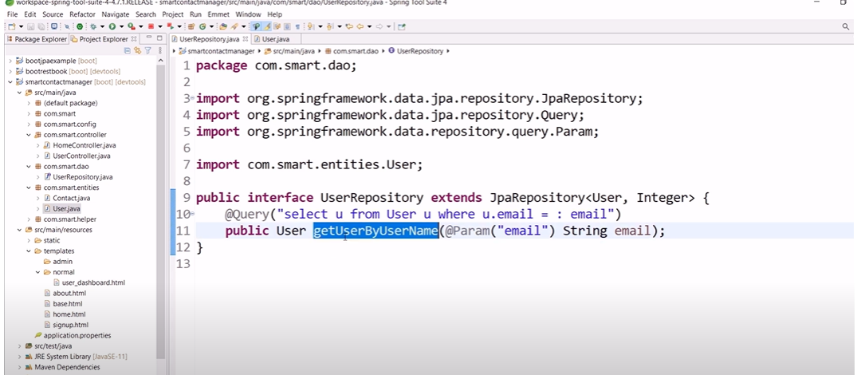

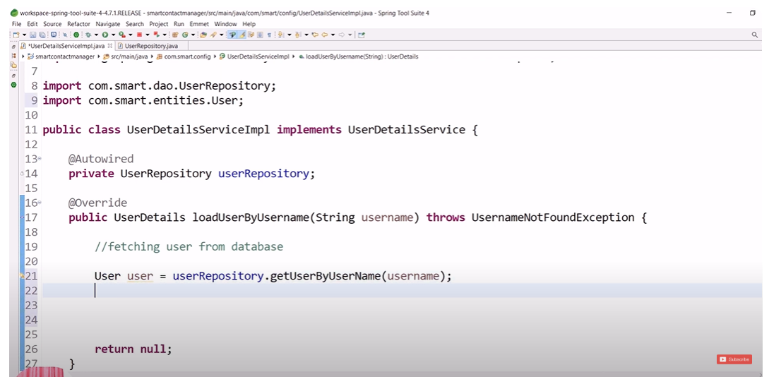

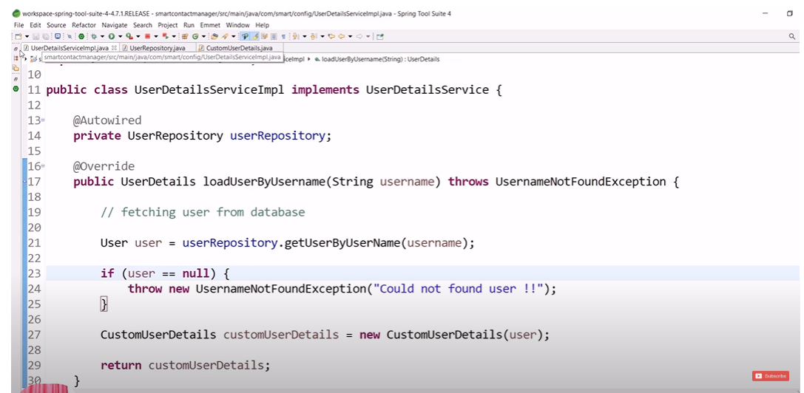

SPRING Boot application:

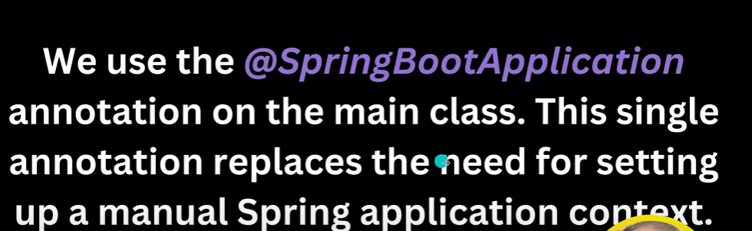



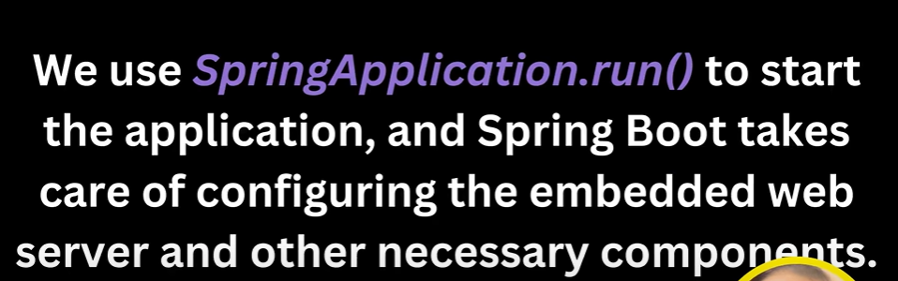

Maven Lifecycle:

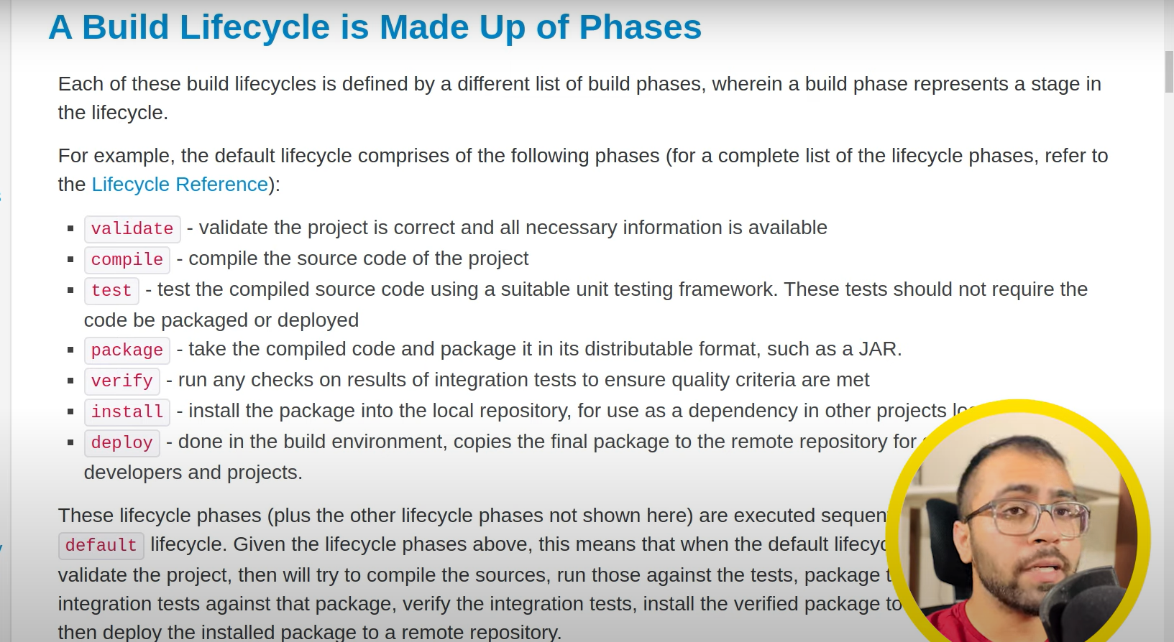

If we don’t have the maven install in the system, we need to use the **mvnw,** which is provided by the spring project itself as shown below and we run like following:

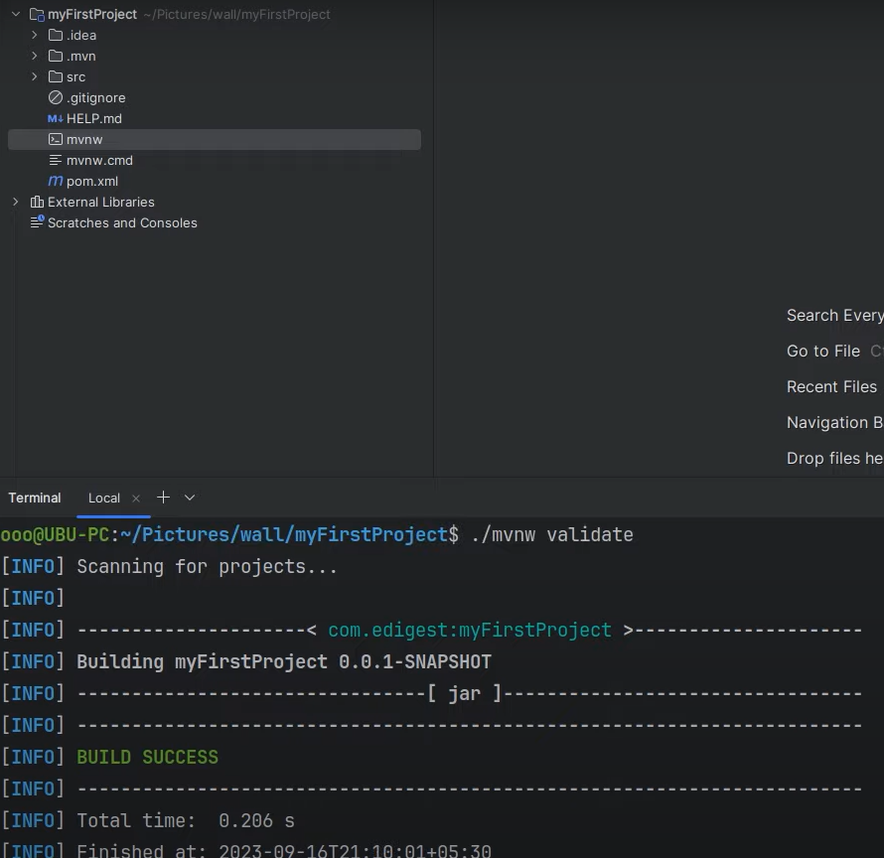

**mvn package** makes the jar file one named as

1. ***myFirstProject-0.0.1-SNAPSHOT.jar***: is a fat jar and contains all the dependencies as well as code.
2. ***myFirstProject-0.0.1-SNAPSHOT.jar.original***: contains only the compiled code.

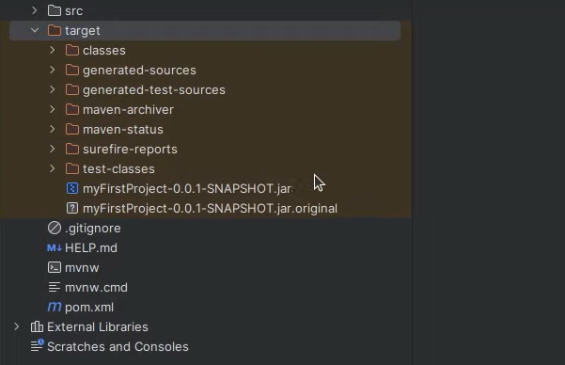

mvn clean clear outs the target folder

.gitignore is the file, in which we need to ignore the things which we don’t need to commit. Example:

/target folder not need to commit.

.idea, *.iws, *.iml and *.ipr files we need to ignore during the commit.

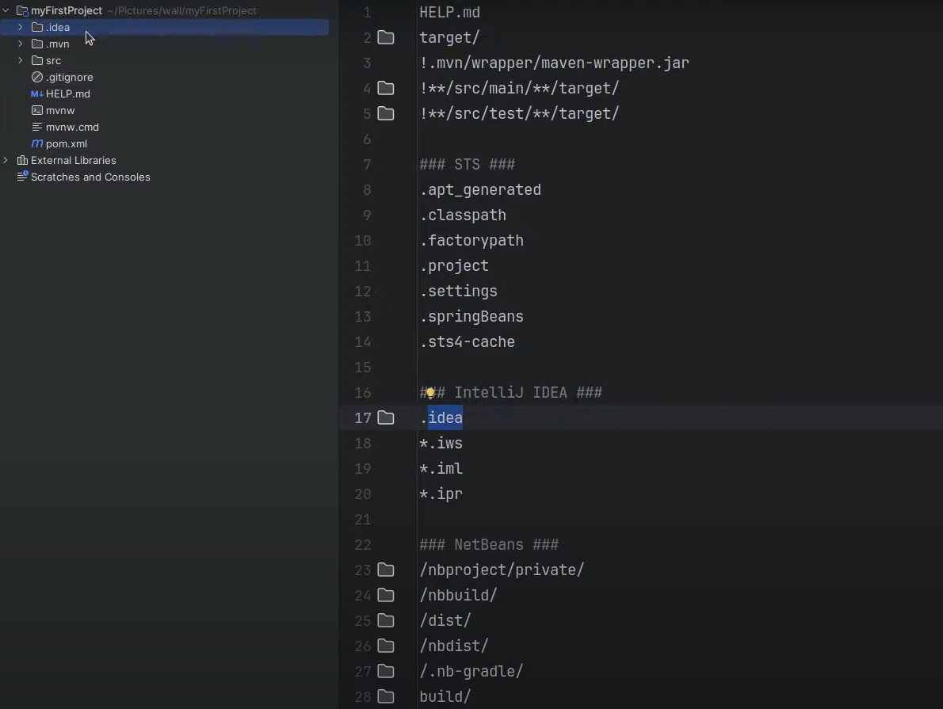

<parent> tag means we inherit the properties from the parent part which includes a lot of dependencies.

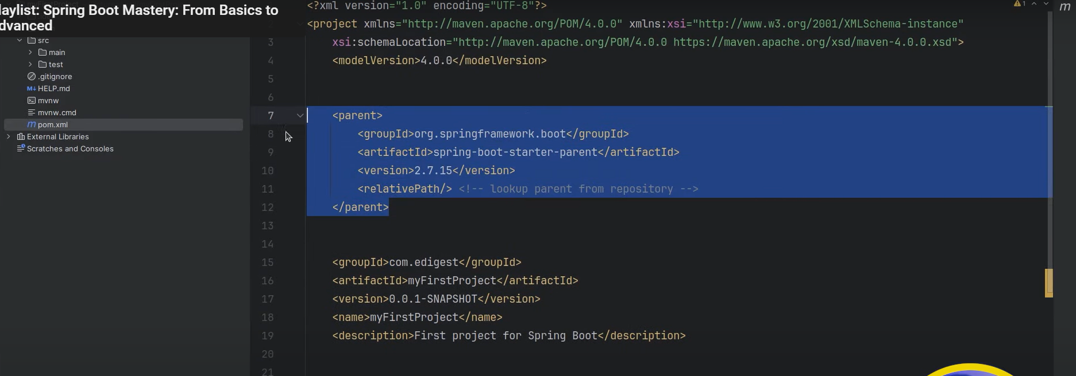

Spring Boot plugin helps to make the jar or war file for the project on which we are working.

And also due to this plugin, repackaging is done, which is from the jar.original to the .jar file.

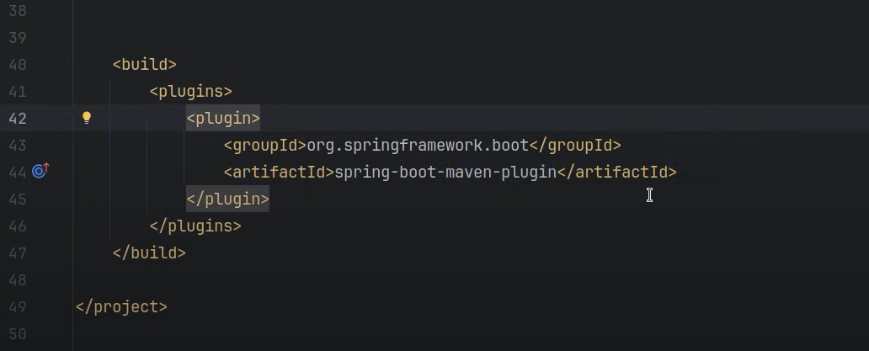

***INVERSION OF CONTROL:***

User does not create the object but asks the spring container to create the object when needed. So, we don’t create object using:

Car car = new Car();

And Application Context is a way to achieve IOC container.

***IOC Container automatically scans the classes which are marked with @Component. And that class is registered as a spring bean***

Example:

@Component

public class MyComponent{}

@SpringBootApplication do this following work:

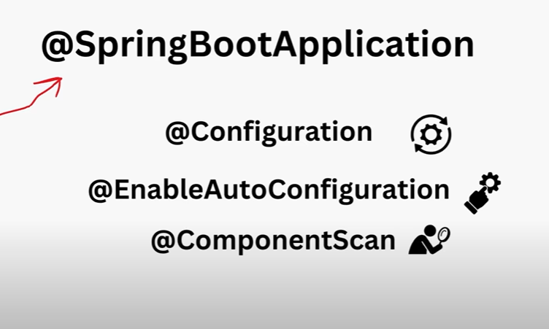

@EnableAutoConfiguration itself configures the configurations. Example: we provide the MongoDB dependencies in pom.xml and provide the configurations in properties file, spring boot automatically creates the connections.

If URL is like: <http://localhost:8080/project?name>:

So, name is the request parameter, which is set as @RequestParam

And if the URL is like <http://localhost:8080/project/name>:

Then name is @PathVariable.

MongoDB commands:

Db.students.find() will print all and db.students.pretty() will make it look good and display better.

To insert: db.st udents.insertOne({“name”:”Deevanshu”});

To find: db.students.find({name:”Deevanshu”})

To delete: db.students.deleteOne({name:”Deevanshu”})

JPA is a way to achieve ORM:



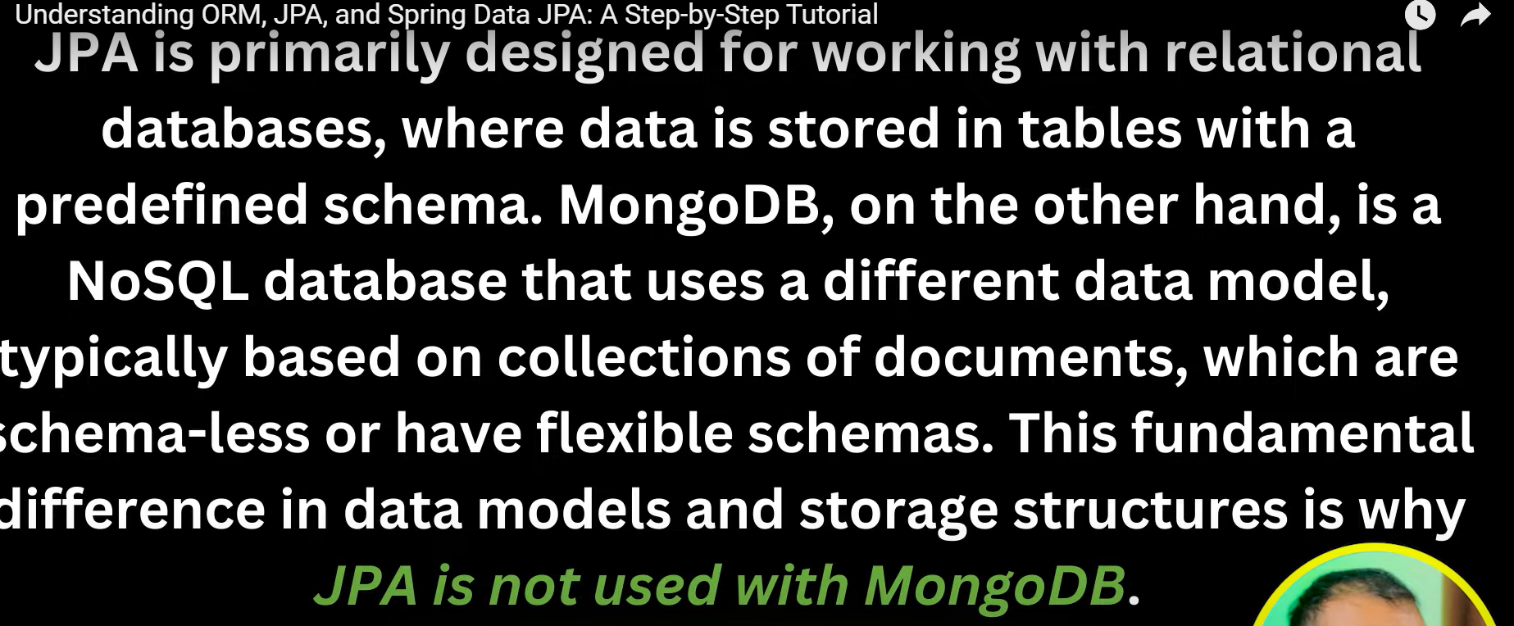

ObjectID has been converted to timestamp and date when used in Spring boot as shown below, but to find we need to pass the id which is there in the record in the MongoDB.

